**Experiment 9**

**Aim:** Uploading Artifacts on Nexus server using command line.

**Procedure:**

**Step 1:** Make the following changes to the settings.xml file of maven.

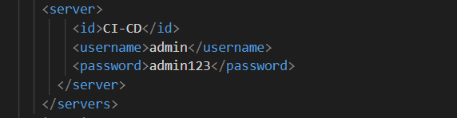

**Step 2:** Make the following changes to the pom.xml file of the project.

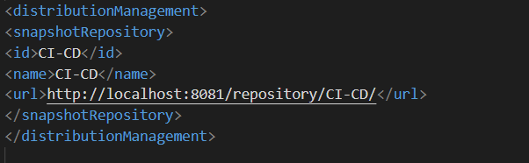

**Step 3:** Start the nexus server

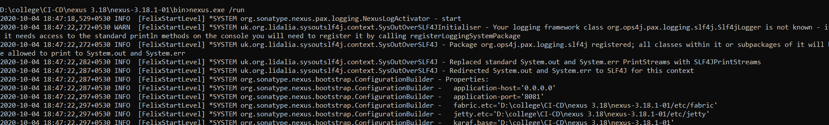

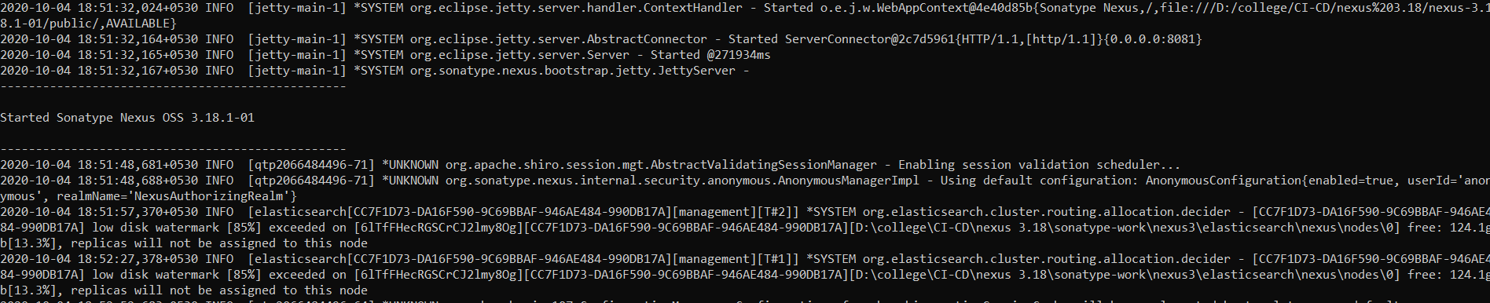

**Step 4:** Create a repository in the nexus dashboard of maven2(hosted) type. Configure the repository in the following way.

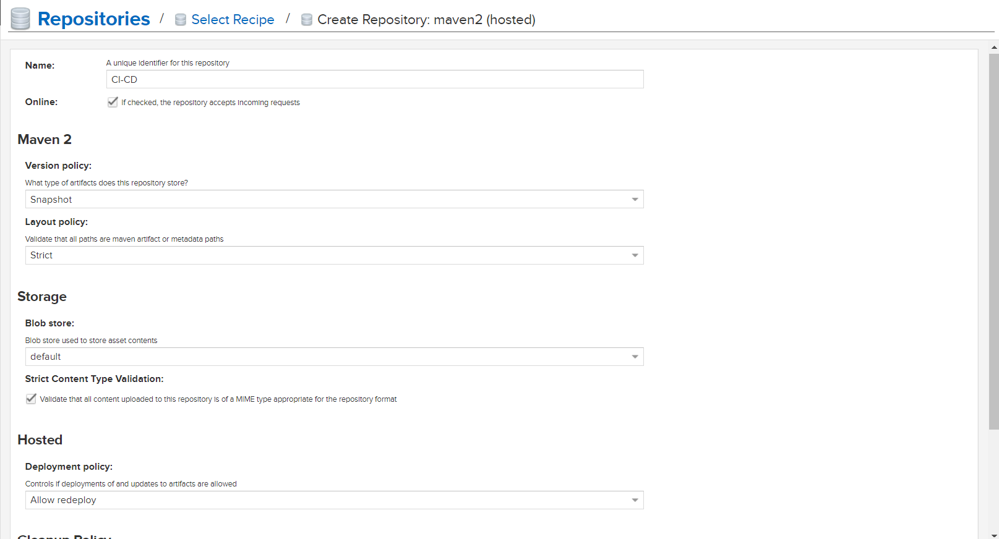

**Step 5:** Run the ‘mvn deploy’ command that will run all the mvn goals and then upload the project on the nexus server.

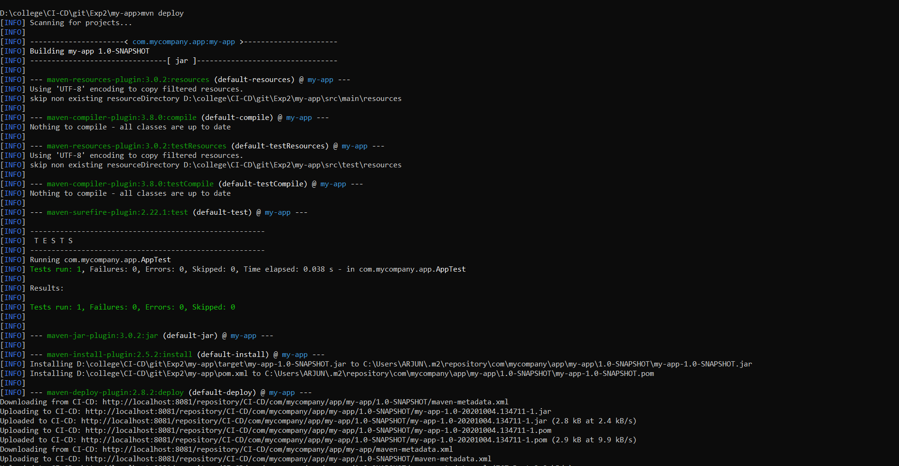

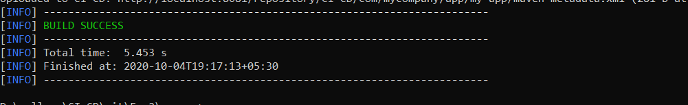

**Step 6:** The following project can now be seen on the nexus dashboard.

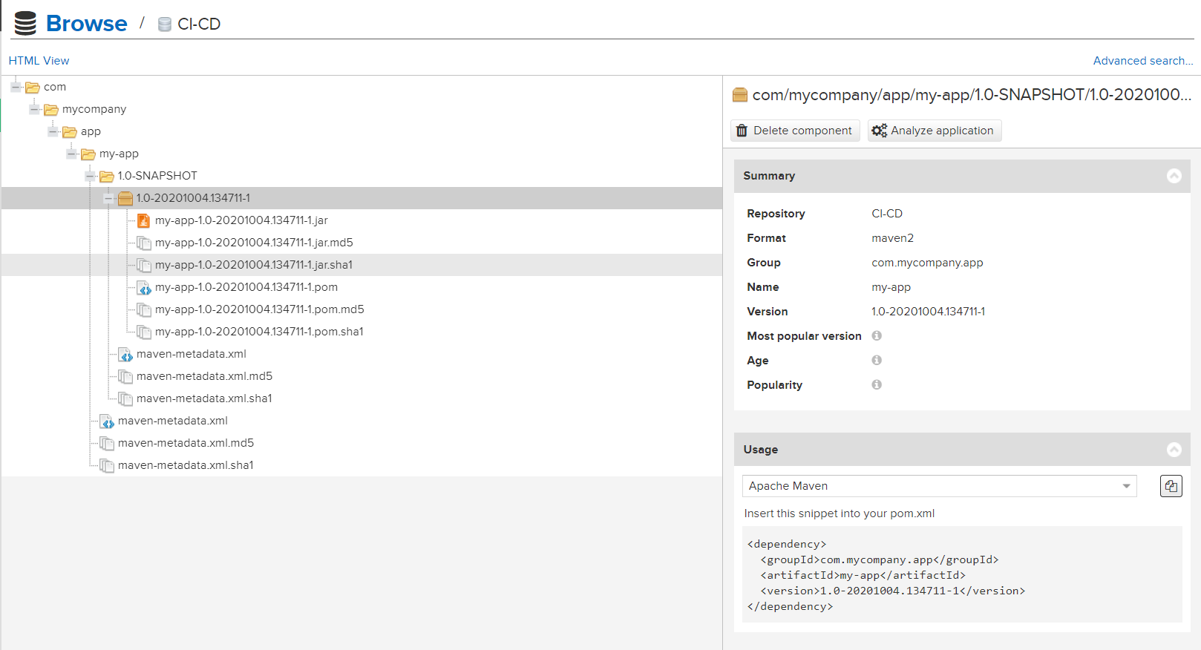

Submitted by:

Arjun Rekhi

500068109

R171218028